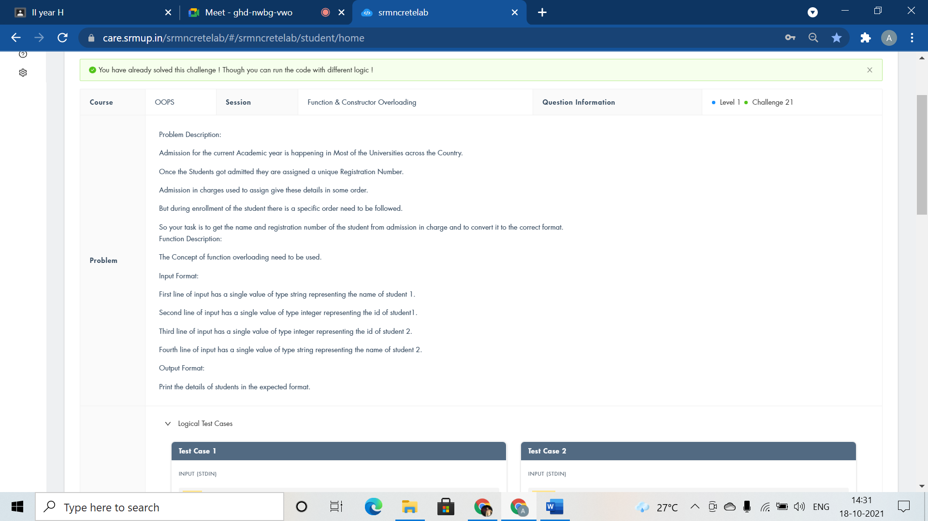

#include <iostream>

using namespace std;

class Student

{

public:

void Identity(string name,int id){

cout<<name<<" "<<id<<endl;

}

void Identity(int id,string name){

cout<<name<<" "<<id<<endl;

}

};

int main()

{

Student Details;

string name;

int id;

cin>>name>>id;

Details.Identity(name,id);

cin>>id>>name;

Details.Identity(id,name);

return 0;

}

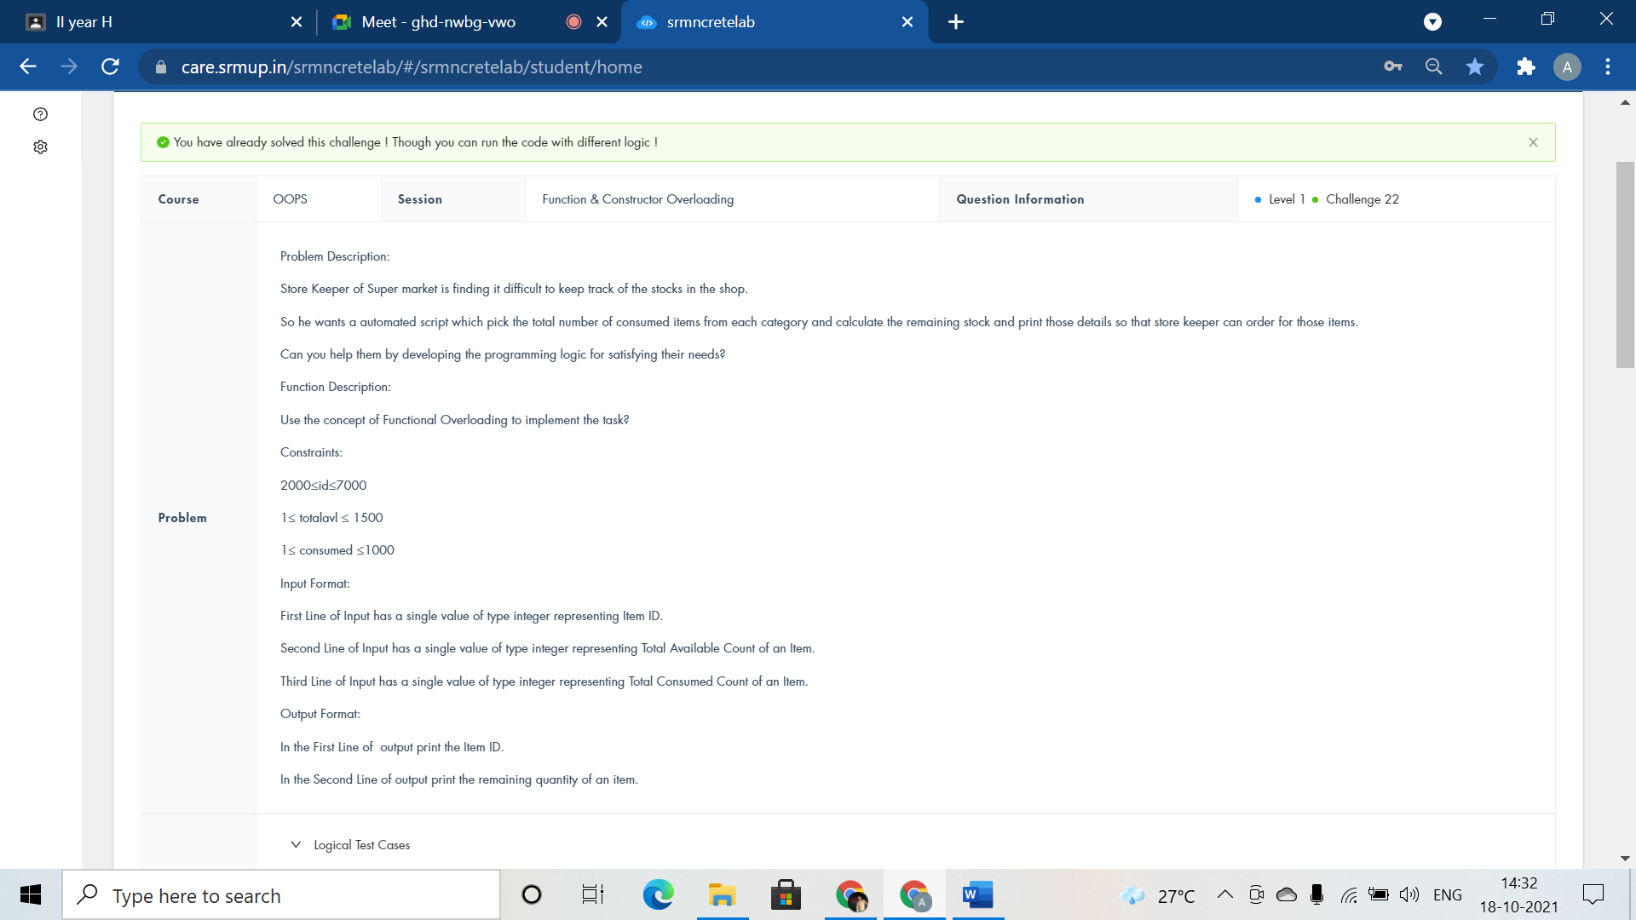

#include <iostream>

using namespace std;

class Store{

public:

void itemcount(int id){

cout<<id<<endl;

}

void itemcount(int totalavl,int consumed){

cout<<totalavl - consumed<<endl;

}

};

int main()

{

Store purchase;

int id,totalavl,consumed;

cin>>id>>totalavl>>consumed;

purchase.itemcount(id);

purchase.itemcount(totalavl,consumed);

return 0;

}

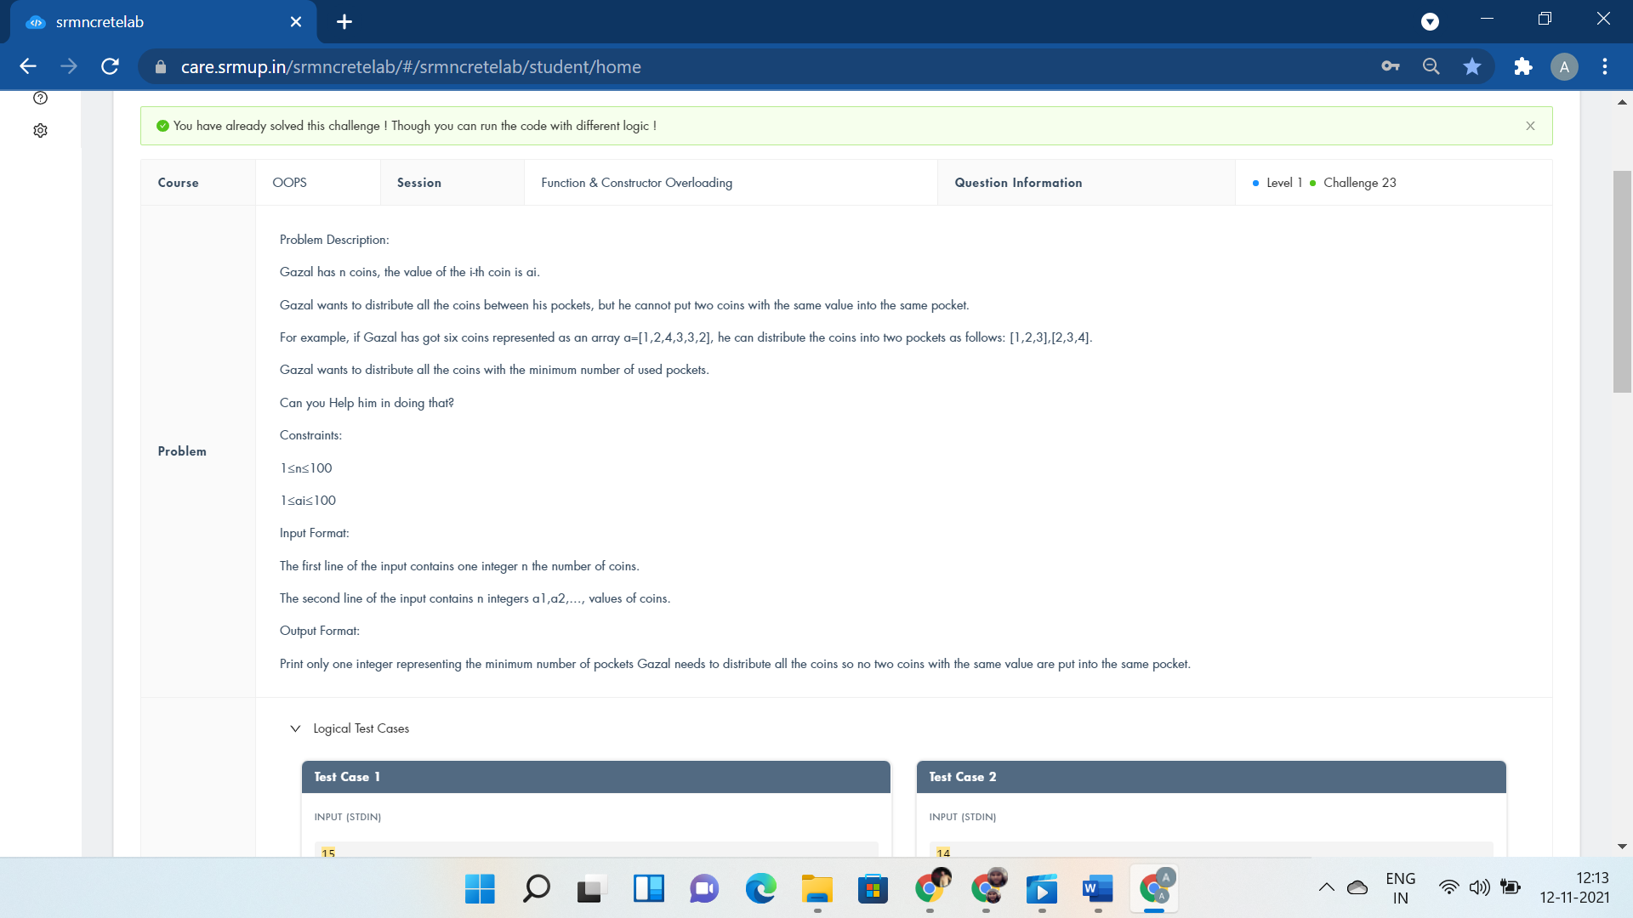

#include<bits/stdc++.h>

using namespace std;

int i,n,a,mx=INT_MIN,c[1000];

int res(int n);

int dis(int n,int mx);

int main(){

cin>>n;

mx=res(n);

cout<<dis(n,mx);

return 0;

cout<<"int* GazalCoin(int arr[],int n) int* GazalCoin(int arr[],int n,int i) GazalCoin(arr,n,0);";

}

int res(int n){

for(i=0;i<n;i++){

cin>>a;

c[a]++;

mx=max(mx,c[a]);

}

return mx;

}

int dis(int n,int mx){

if(n%mx==1 && n%11!=0)

return mx+1;

if(n%mx==1 && n%11 == 0)

return mx;

if(n%mx==2)

return mx+1;

return mx;

}

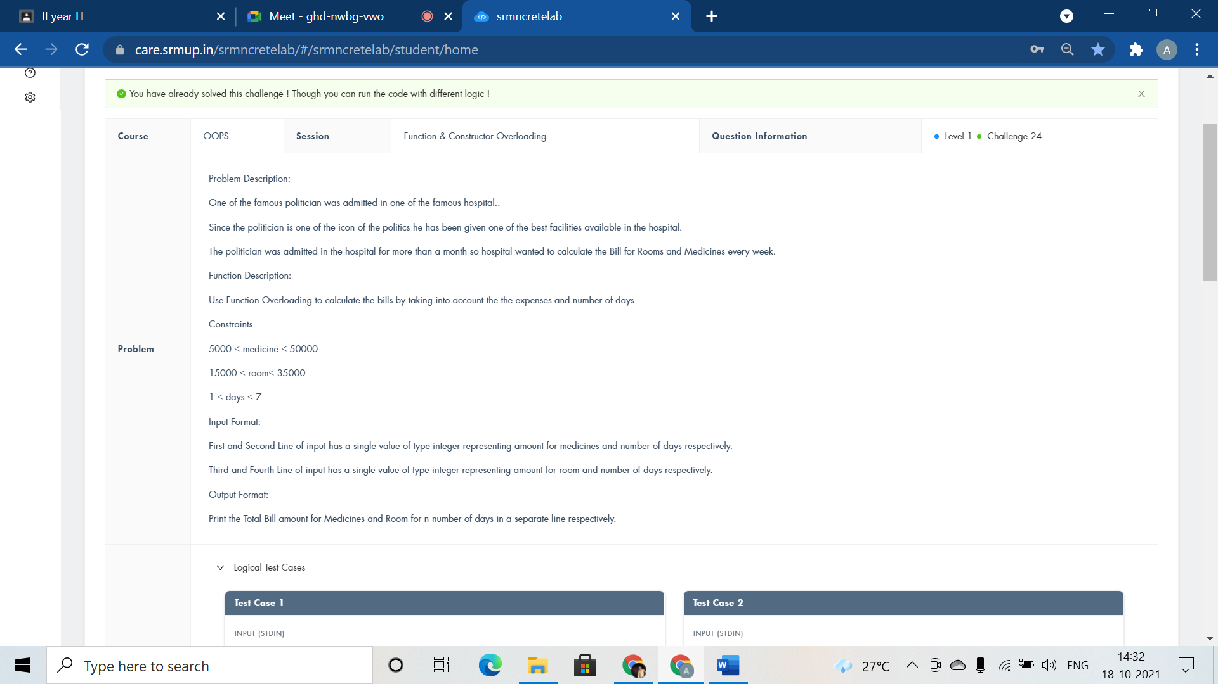

#include <iostream>

using namespace std;

class Hospital{

public:

void bill(long int mdeicinebill,int days){

cout<<mdeicinebill*days<<endl;

}

void bill(int roomrent,int days){

cout<<roomrent*days;

}

};

int main()

{

Hospital ob;

long int mdeicinebill,days;

int roomrent;

cin>>mdeicinebill>>days;

ob.bill(mdeicinebill,days);

cin>>roomrent>>days;

ob.bill(roomrent,days);

return 0;

}

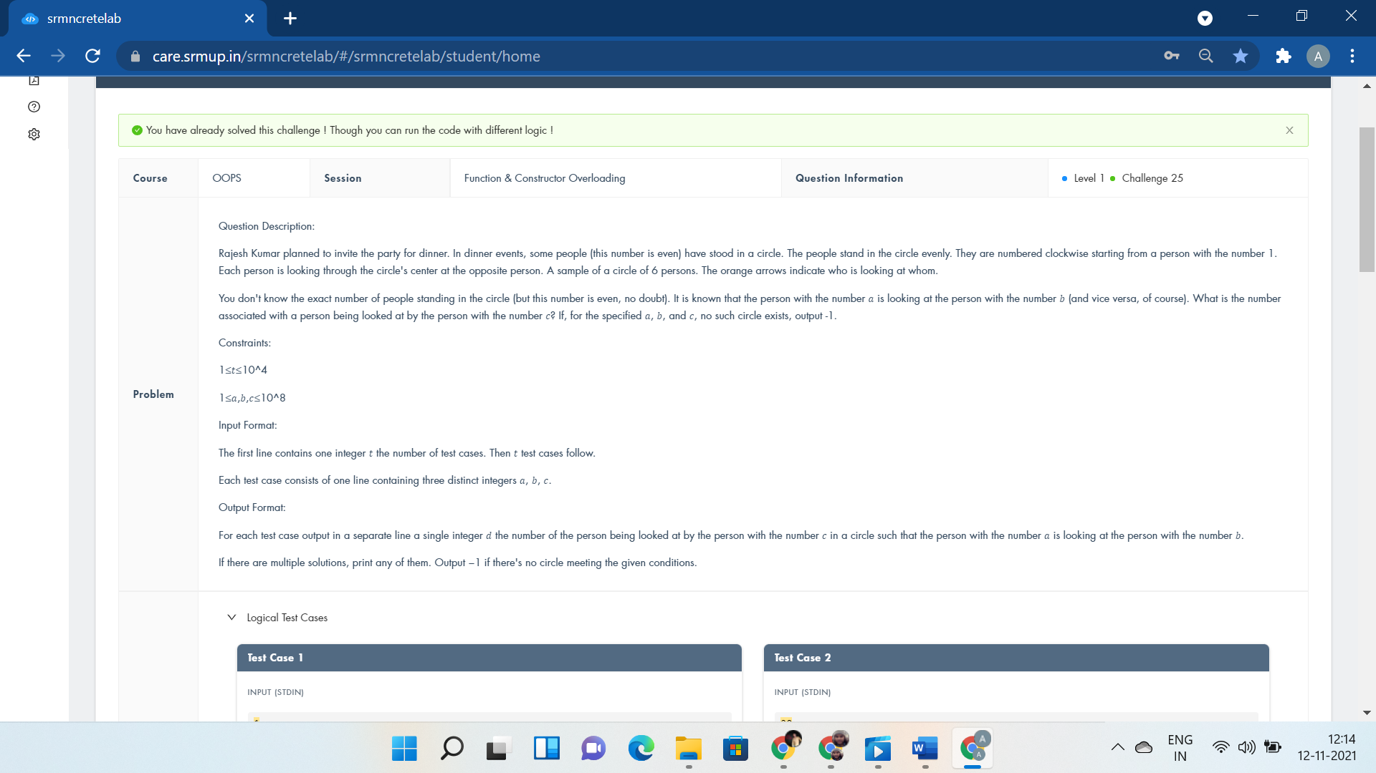

#include<bits/stdc++.h>

using namespace std;

int i,T,a,b,c,n;

#define f(i,a,n) for(i=a;i<n;i++)

class solve{

public:

void get(){

std::cin>>a>>b>>c;

n=2*abs(a-b);

}

void get2(){

if(c>n||max(a,b)>n)

cout<<"-1"<<endl;

else if(c>n/2)

cout<<c-n/2<<endl;

else

cout<<c+n/2<<endl;

}

};

int main(){

cin>>T;

solve p;

f(i,0,T){

p.get();

p.get2();

}

return 0;

cout<<"void pline(int v[],int n) void pline(int v) else if(x>n||x<=0)";

}

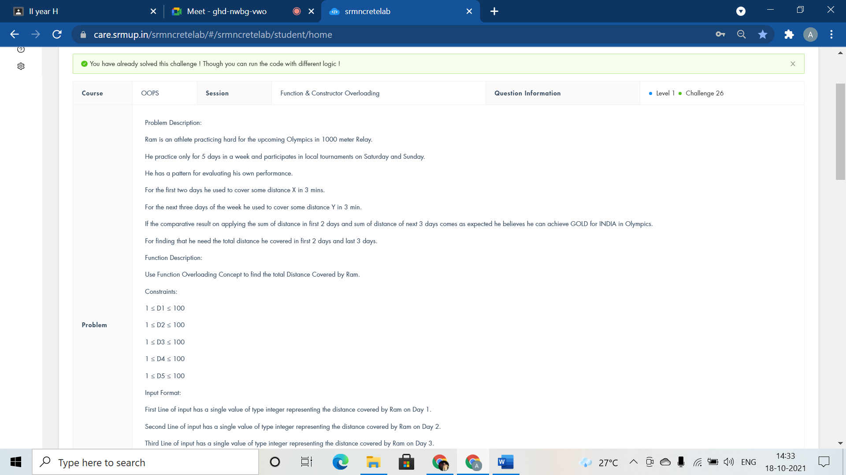

#include <iostream>

using namespace std;

class Olympic{

public:

void distance(int D1,int D2){

cout<<D1+D2<<" meters"<<endl;

}

void distance(int D3, int D4, int D5){

cout<<D3+D4+D5<<" meters"<<endl;

}

};

int main()

{

Olympic Medal;

int D1,D2,D3,D4,D5;

cin>>D1>>D2>>D3>>D4>>D5;

Medal.distance(D1,D2);

Medal.distance(D3,D4,D5);

return 0;

}

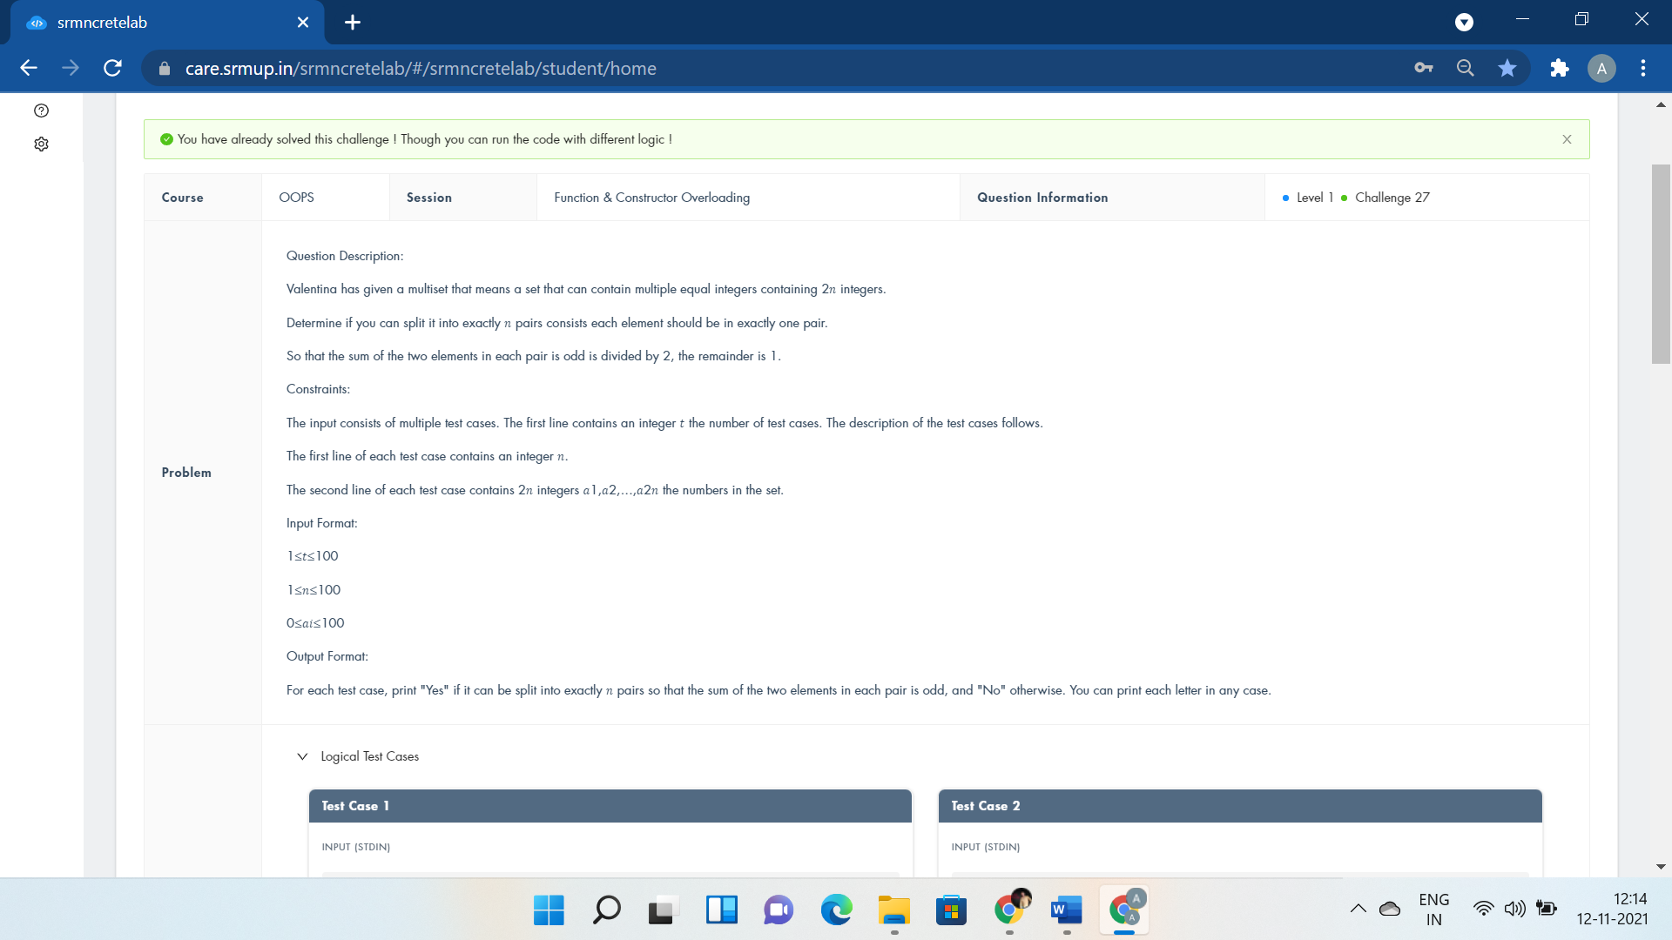

#include <iostream>

using namespace std;

int power(int x,int p);

int power(int x,int y,int p);

int main()

{

int t;

cin>>t;

while(t--){

int n,odd=0;

cin>>n;

int z=power(n,odd);

//cout<<n<<z;

power(n,z,1);

}

return 0;

}

int power(int x,int p){

int a[2*x];

for(int i=0;i<2*x;i++){

cin>>a[i];

if(a[i]%2==1)

p++;

}

return p;

}

int power(int x,int y,int p){

if(x==y)

cout<<"Yes"<<endl;

else

cout<<"No"<<endl;

return 1;

}

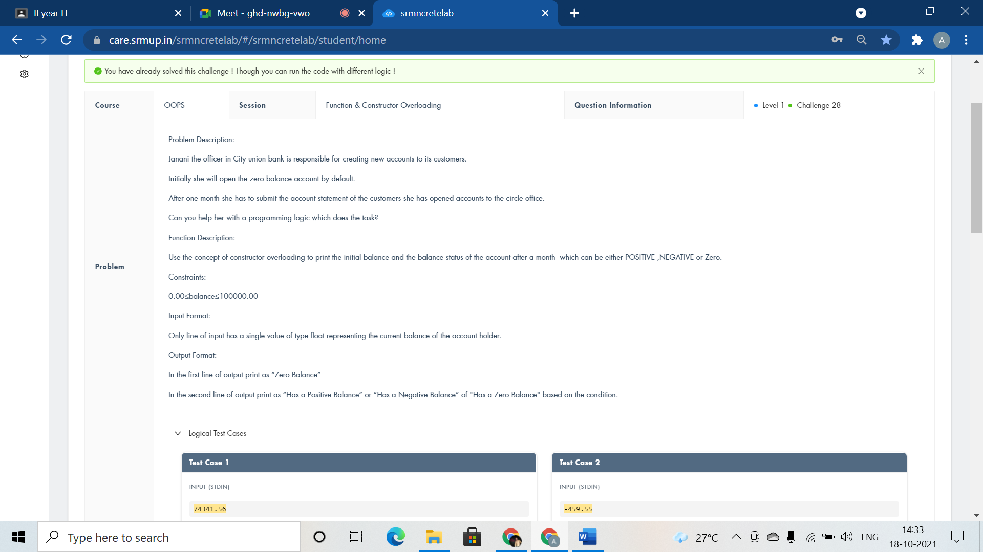

#include <iostream>

using namespace std;

class AccBalance{

public:

AccBalance(){cout<<"Zero Balance"<<endl;}

AccBalance(int balance){

if(balance<0)

cout<<"Has a Negative Balance";

else if(balance==0)

cout<<"Has a Zero Balance";

else

cout<<"Has a Positive Balance";

}

};

int main()

{

AccBalance defltBal;

int balance;

cin>>balance;

AccBalance currBal(balance);

return 0;

}

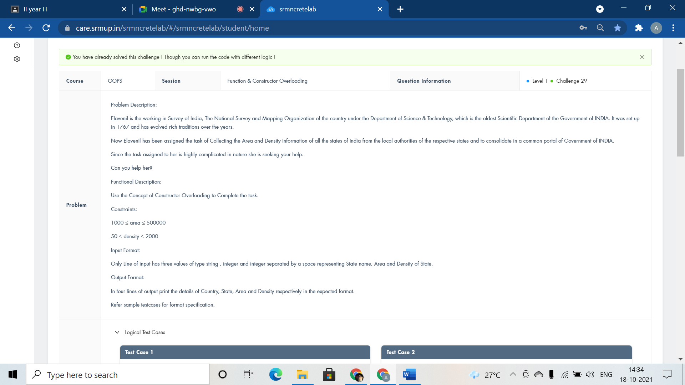

#include <iostream>

using namespace std;

class Country{

public:

Country(){cout<<"Country:INDIA"<<endl;}

Country(char statename[100],int area,int density)

{

cout<<"State:"<<statename<<endl<<"Area:"<<area<<endl<<"Density:"<<density<<endl;

}

};

int main()

{

Country country;

char statename[100];

int area,density;

cin>>statename>>area>>density;

Country statesofindia(statename,area,density);

return 0;

}

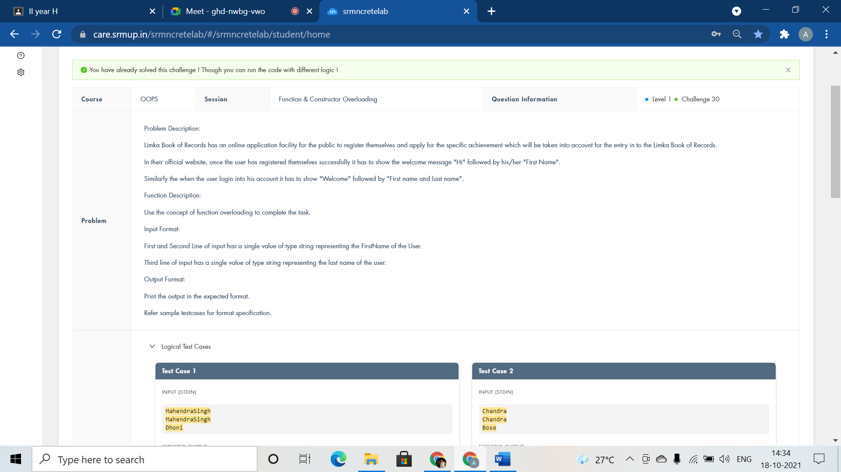

#include <iostream>

using namespace std;

class Welcomemsg{

public:

void msg(string fname){

cout<<"Hi "<<fname<<endl;

}

void msg(string fname,string lname){

cout<<"Welcome "<<fname<<" "<<lname;

}

};

int main()

{

Welcomemsg ob;

string fname,lname;

cin>>fname;

ob.msg(fname);

cin>>fname>>lname;

ob.msg(fname,lname);

return 0;

}